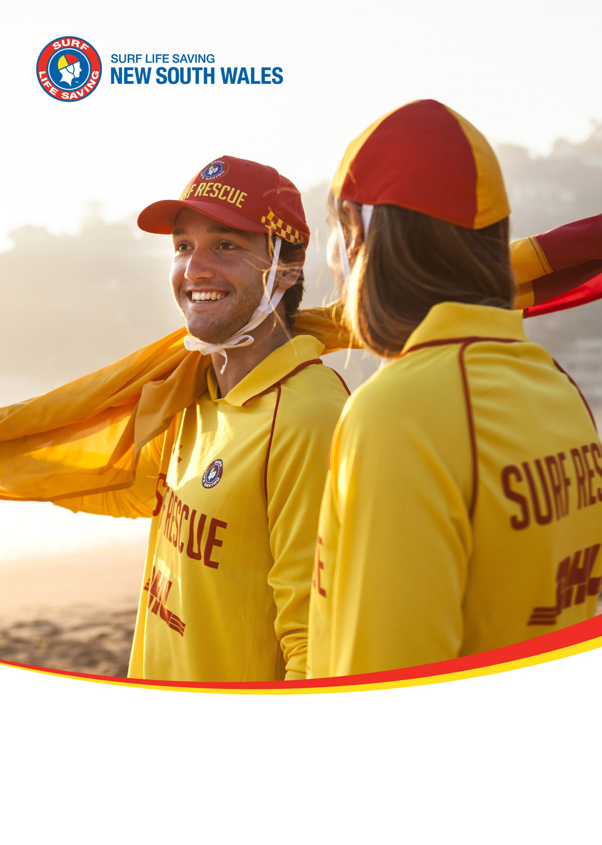
Redhead SLSC
Patrol Operations Manual 2018/19
1 Communication 3
1.1 Surf Life Saving & Emergency Services 3
1.2 Club Callout Team 4
1.3 Club Radio Procedures 5
2 Hazard/Risk Management 6
2.1 Hazard/Risk Map 6
2.2 Hazard/Risk Management Plan 7
2.3 Northern Emergency Response Area 7
2.4 Southern Emergency Response Area 7
3 Beach Management 8
3.1 Minimum Patrol Requirements 8
3.1.1 Personnel 8
3.1.2 Equipment 8
3.2 Patrol Types 9
3.2.1 Base Patrol 9
3.2.2 Satellite Patrol 10
3.2.3 Outpost Patrol 10
3.2.4 Beach Closed Patrol 10
3.3 Daily Patrol Procedures 11
3.3.1 Start of patrol 11
3.3.2 End of patrol 11
3.3.3 Equipment Location 11
3.4 Nippers/Water Safety 12
3.5 Club Rules 12
3.6 Local Government By-Laws 12
3.7 Patrol Breaches 13
3.7.1 Breach Identification 13
3.7.2 Breach Levels 13
3.7.3 Breach Penalties 14
4 Emergency Operations Plans 15
4.1 Emergency Beach Closure 15
4.2 Emergency Beach Closure Procedure 15
4.3 Closure Periods 15
4.4 Tsunami Plan 16
4.4.1 Notification 16
4.4.2 Key Equipment 17
4.4.3 Marine Threat Response 17
4.4.4 Land Threat Response 17
4.5 Coastal Flooding Plan 18
4.5.1 Coastal Flooding Response 18
4.6 Emergency Rally Point 19
4.7 Helicopter Landing Zone 20
5 Standard Operating Procedures 21

Communication

Surf Life Saving & Emergency Services
SurfCom
Service |  | Phone |  |  | Email
State Operations Centre  Branches covered;  - Far North Coast  - North Coast  - Mid North Coast  - Lower North Coast  - Hunter  - Central Coast  - Sydney  - Illawarra |  | 02 9471 8092 |  |  | soc@surflifesaving.com.au
SurfCom (Fisherman’s Beach)  Branches covered;  - Sydney Northern Beaches  - South Coast  - Far South Coast |  | 02 9982 5666 |  |  | surfcom@surflifesaving.net.au
Emergency services such as Police, Ambulance, Fire, Helicopters, Roads and Maritime Services, Marine Rescue, National Parks and Wildlife Services and the NSW Department of Fisheries should be requested via SurfCom
Surrounding Surf Life Saving Assets
Club/Service |  | Contact |  | Distance | Response Time (Water) |  | Response Time (Land)
Branch Duty Officer ??? |  | 0419 965 570 |  | N/A | N/A |  | N/A
Redhead Club Captain –Hayley Churchill |  | 0422733256 |  |  |  |  | 10 min
Redhead Vice Club Captain –  Luke Nolan |  | 0414 486 750 |  |  |  |  | 10 mins
Redhead Vice Club Captain –  Sharon Greenland |  | 0408 615 211 |  |  |  |  | 25 mins
President – Steve Foggett |  | 0417313589 |  |  |  |  | 5 mins
Other Stakeholders
Assure Programs (Counselling) | 1800 808 374 |  | NSW Poisons Info |  |  | 131 126

Club Callout Team
Each Club should have an ‘Emergency Callout Team’ that can respond to incidents within the ‘Emergency Response Area’ as outlined in the Lifesaving Service Agreement. Members of the ‘Emergency Callout Team’ are to be appointed by the Club Captain and a list of active members maintained via SurfGuard.
To maximise emergency response effectiveness and personnel safety, clubs should maintain the following equipment/logistical preparedness;
- 2 x rescue tubes (with fins)
- 2 x rescue boards
- IRB (with trailer and full fuel bladder in an accessible location)
- ATV (if applicable)
- 1 x defibrillator
- 1 x oxy resuscitation kit
- 1 x first aid kit
- 1 x spinal board (with spinal collars)
- 2 x handheld radios in waterproof bags
- Personal telephone numbers contactable 24 hours with contacts (updated in SurfGuard)
Name | Phone | Email
Gavin Ekert | 0415 501023 | gavinekert@hotmail.com
Steve Foggett | 0417 313 589 | steve.foggett@homemail.com.au
Iain Robertson | 0417 693 732 | iain.robertson@onesteel.com
Dean Little | 0400 554 058 | dean@oceanplayground.com.au
Matthew Kent | 0434 398 918 | luckykent@hotmail.com
Col Ekert | 0403 314 497 | colekert@hotmail.com
Shane Abrahamson | 0438 449 590 | shane5055@bigpond.com
Chris Bird | 0447 766 113 | clhmbird@gmail.com
Andrew Wright | 0409 844 940 | pup.kel@bigpond.com
Adam Rees | 0404555862 | areesfire@gmail.com

Club Radio Procedures
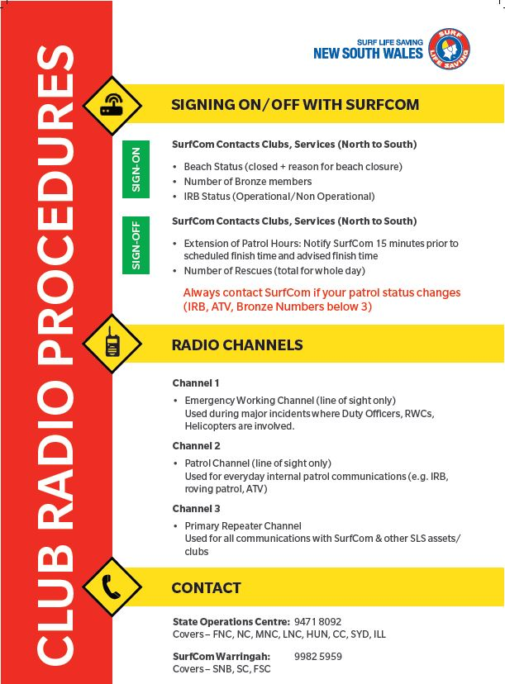

Hazard/Risk Management

Hazard/Risk Map
 | A | B | C | D | E | F | G | H | I | J | K | L | M | N
17 |  |  |  |  |  |  |  |  |  |  |  |  |  |  | 17
16 |  |  |  |  |  |  |  |  |  |  |  |  |  |  | 16
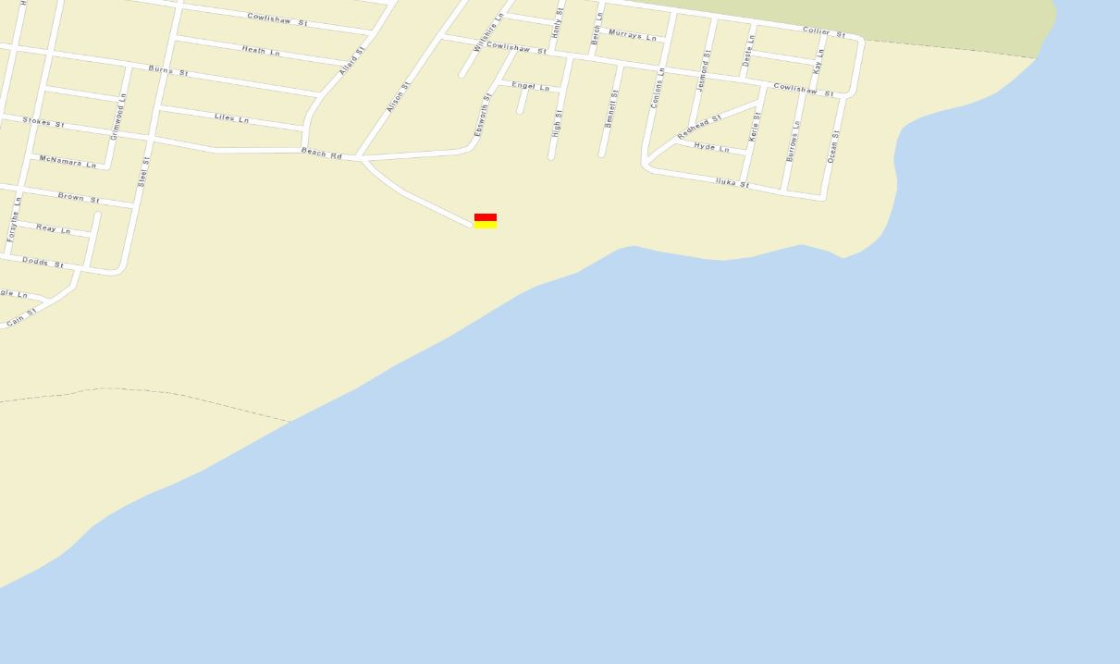  15 |  |  |  |  |  |  |  |  |  |  |  |  |  |  | 15
14 |  |  |  |  |  |  |  |  |  |  |  |  |  |  | 14
13 |  |  |  |  |  |  |  |  |  |  |  |  |  |  | 13
12 |  |  |  |  |  |  |  |  |  |  |  |  |  |  | 12
11 |  |  |  |  |  |  |  |  |  |  |  |  |  |  | 11
10 |  |  |  |  |  |  |  |  |  |  |  |  |  |  | 10
9 |  |  |  |  |  |  |  |  |  |  |  |  |  |  | 9
8 |  |  |  |  |  |  |  |  |  |  |  |  |  |  | 8
7 |  |  |  |  |  |  |  |  |  |  |  |  |  |  | 7
6  Primary patrol area  From: Redhead Bluff (I7)  To: First Creek (F12)  Secondary patrol area  From: First Creek (F12)  To: Second Creek (E14) |  |  |  |  |  |  |  |  |  |  |  |  |  |  | 6
5 |  |  |  |  |  |  |  |  |  |  |  |  |  |  | 5
4 |  |  |  |  |  |  |  |  |  |  |  |  |  |  | 4
3 |  |  |  |  |  |  |  |  |  |  |  |  |  |  | 3
2 |  |  |  |  |  |  |  |  |  |  |  |  |  |  | 2
1 |  |  |  |  |  |  |  |  |  |  |  |  |  |  | 1
 | A | B | C | D | E | F | G | H | I | J | K | L | M | N

Hazard/Risk Management Plan
Hazard/Risk | Location (Grid Ref) | Management Plan
Fishing from Rocks | I 8 (northern rocks) | Monitor area from clubhouse with binoculars and roving patrols  Equipment: Binoculars, Radio, Tube  Response: IRB and ATV
Flash Rips | I 9 (base of Shark Tower) | Monitor area from clubhouse with binoculars  Equipment: Board, tube  Response: Immediate board and tube
Dogs | E 14 (north) | Monitor dogs off lead  Equipment:  Response: Council Ranger if needed
Equipment:
Response:
Equipment:
Response:
Equipment:
Response:

Northern Emergency Response Area
Area | I 7 to F 12 (Redhead Bluff to First Creek)
Equipment | IRB, ATV, Board, Tube, Binoculars, First Aid Kit, Spinal Board, Oxy Viva
Response | IRB, ATV, Board, Tube
Response Time (water - IRB) | 2 to 3 mins
Response Time (land - ATV) | 2 to 3 mins
Access (boat ramps etc) | First entry point – north end of club house  Second entry point – First Creek

Southern Emergency Response Area
Area | F12 to C17 (First Creek to Third Creek)
Equipment | IRB, ATV, Board, Tube, Binoculars, First Aid Kit, Spinal Board, Oxy Viva
Response | IRB, ATV, Board, Tube
Response Time (water - IRB) | 5 to 10 mins
Response Time (land - ATV) | 10 to 15 mins
Access (boat ramps etc) | First entry point – north end of club house  Second entry point – First Creek

Beach Management

Minimum Patrol Requirements

Personnel
A patrol is to consist of a minimum of three (3) personnel, with the below qualifications held amongst the three (3) members;
- 3 x bronze medallion
- 1 x Advanced Resuscitation Techniques Certificate (ARTC)
- 1 x IRB driver
- 1 x IRB crew
- 1 x Basic Beach Management (held by Patrol Captain)

Equipment
A patrol is to set up their beach with items of equipment, as a minimum;
- IRB (with trailer)
- Rescue craft access signs (where an IRB/RWC is launched from)
- 3 x handheld radios in waterproof bags
- 2 x ‘swimming not advised’ (or ‘beach closed) mobile signs
- Patrol information board
- ATV/vehicle (where applicable)
- Tower or shade (tent)
- 2 x rescue boards
- 3 x rescue tubes
- 1 x defibrillator
- 1 x oxy resuscitation kit
- 1 x first aid kit
- 1 x spinal board
- 1 x binoculars
- Set of red and yellow feathered patrol flags
- Set of black and white chequered surfcraft boundary flags

Patrol Types
For detailed descriptions of the various patrol types that can be conducted, please refer to the Standard Operating Procedures, LS4.3 Club Patrol Types.
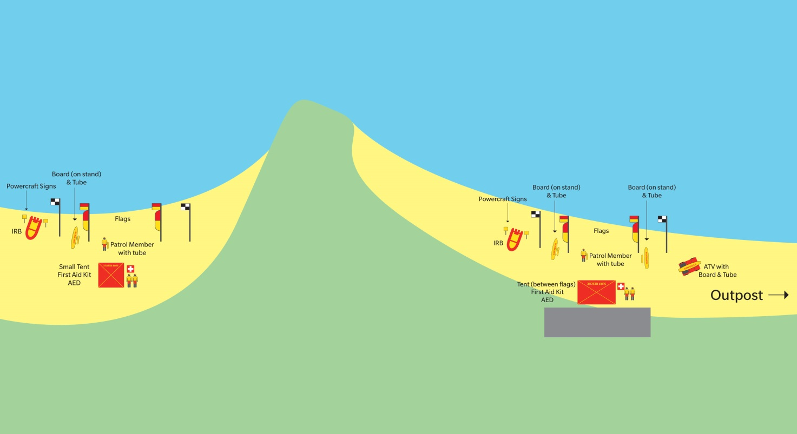

Base Patrol
A Base Patrol is the core patrolled area for a lifesaving service established at all times and dates as identified in the Lifesaving Service Agreement. A Base Patrol must meet all minimums for personnel and equipment as stated below to be considered ‘beach open’.
A Base Patrol may be supported by multiple Sub Patrols to effectively manage the beach operations as identified in the services Patrol Operations Manual.
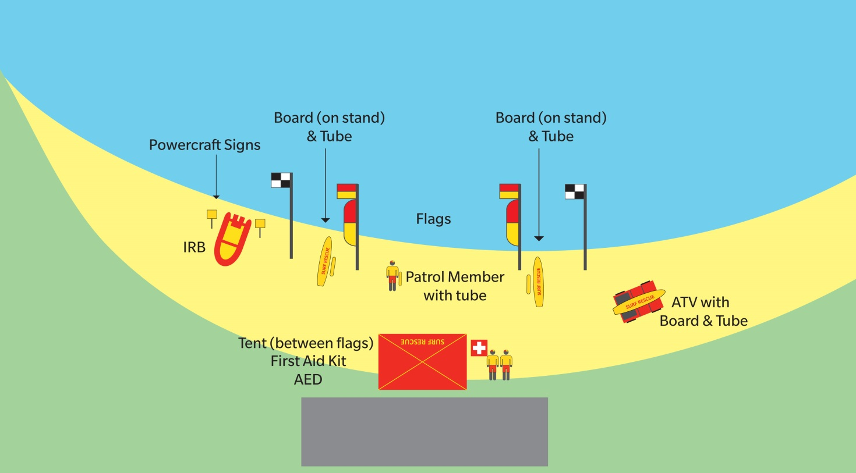

Satellite Patrol
A Satellite Patrol is a sub patrol type with patrol flags, and operates as an extension of the Base Patrol, as defined within the services’ Patrol Operations Manual to provide surveillance at an area of high risk. A Satellite Patrol may operate almost independently of a Base Patrol due to similar minimum requirements.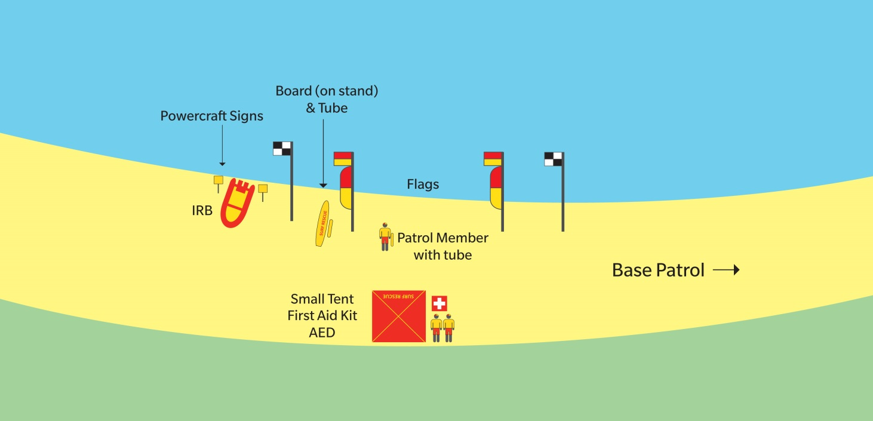

Outpost Patrol
An Outpost Patrol is established at other areas of coastline. This sub patrol type has no patrol flags, and operates as an extension of the Base Patrol, as defined within the services’ Patrol Operations Manual to
provide surveillance at an area of high risk.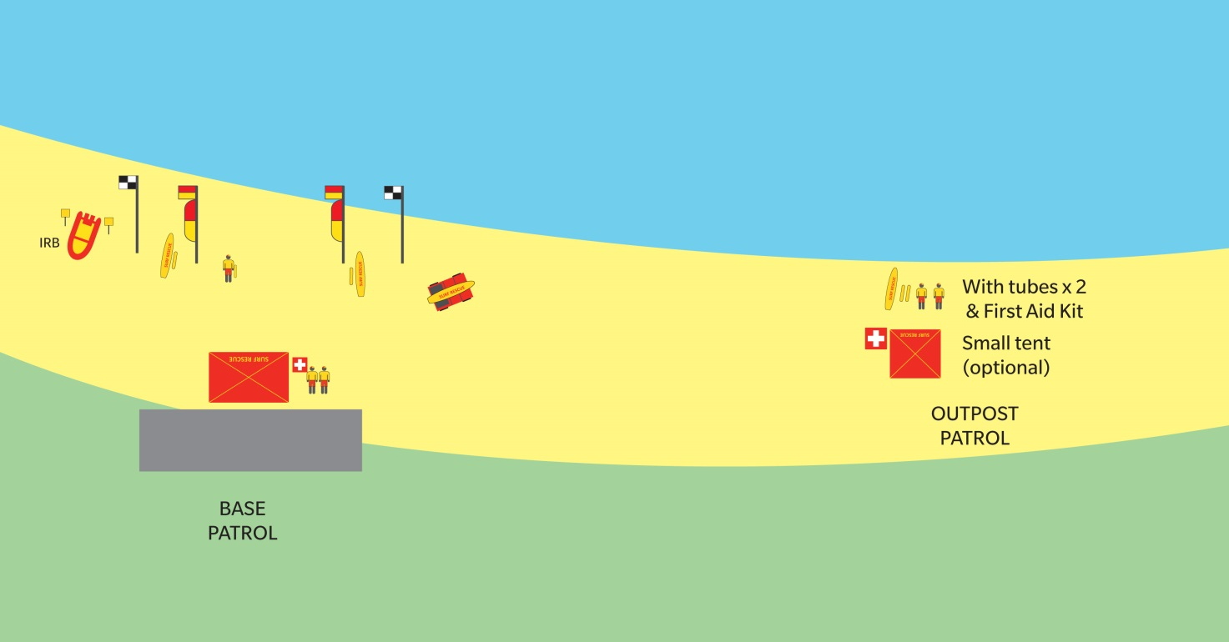

Beach Closed Patrol
A Beach Closed Patrol is Base Patrol with a closed swimming area. The swimming area may be closed for situations such as dangerous conditions or an emergency.
A Beach Closed Patrol includes all minimum personnel and all minimum equipment with the exception of patrol flags.

Daily Patrol Procedures
Add/remove items to the below lists as required.

Start of patrol
- All members arrive at least 15min prior to start of patrol
- Minimum standards assessed (numbers, qualifications, gear)
- Equipment should be checked and positioned for patrol
- Flagged area established
- Patrol log completed
- Patrol signed on with SurfCom
- ‘Patrol Briefing’ conducted by Patrol Captain, discussing;
  - Uniform standards
  - Member roles/responsibilities
  - Rotation schedule/positioning
  - Radio use (channels/call-signs)
  - Expected weather/surf conditions
  - Expected hazards and management
  - Induction/introduction of any new members

End of patrol
- Scanning/surveillance of beach maintain by at least one lifesaver during ‘pack-up’
- Rescue equipment (radio, tube, board, IRB) to remain at ‘rescue ready’ status during ‘pack up’
- Patrol log, Incident log and Powercraft log completed
- Patrol signed off with SurfCom
- All equipment cleaned and stored appropriately
- Radio’s placed on charge
- Any supply requirements or equipment damage reported to relevant club officer
- ‘Patrol Debrief’ conducted by Patrol Captain, discussing;
  - Rescues/incidents and key activities from the day
  - Any questions/concerns from patrol members
  - Upcoming events/opportunities
  - Training options
  - Next patrol date

Equipment Location
Add/remove items to the below lists as required.
Item | Location
IRB | IRB Shed (north end of club house)
Radios | Patrol room cabinet – key entry
Patrol shade (tent) | IRB Shed (north end of club house)
Patrol chairs | IRB Shed (north end of club house)
Rescue boards | IRB Shed (north end of club house)
Rescue tubes | IRB Shed (north end of club house)
Defibrillator | Patrol room cabinet – key entry
Oxy resuscitation kit | Patrol room cabinet – key entry
First aid kit | Patrol room cabinet – key entry
Spinal board | IRB Shed (north end of club house)
Binoculars | Patrol room cabinet – key entry
Patrol flags/signage | IRB Shed (north end of club house)

Nippers/Water Safety
Nipper activities (and like activities) are to adhere to the SLSA Water Safety Policy (SLSA Policy 1.01) at all times. Nipper activities are to only be conducted in the immediate vicinity of an active patrolled area and have its own sufficient water safety (minimum 1 water safety for every 5 participants). It is highly recommended that an IRB be available water safety. The IRB should be on the water, rather than stationary on the beach.
Nipper activities cannot be undertaken on a closed beach.
The Patrol Captain is to have ‘control’ over all Nipper activities and may delegate to a Nipper Coordinator.

Club Rules
- Full patrol uniform must always be worn on patrol
- At least one (1) patrol member to always be watching the water
- At least one (1) patrol member always monitoring the radio (channel 2 and channel 3)
- The Patrol Captain is to always be made aware of all member locations/activities
- At least one (1) patrol member at the water’s edge with a tube and radio when swimmers are in the water
- Rescue tubes are to always be carried by patrol members when on the beach
- Rescue tubes should not be tied to flag poles
- Members should not text, sun bathe or engage in any unprofessional behaviour (in uniform) in public view
- Only qualified IRB driver and crew are to operate the IRB
- Only licensed drivers to operate the ATV
- The ATV should always be left facing the water (out of gear and in neutral)
- ATV should always be driven at a low speed (unless in an emergency)
- No passengers are allowed in the tray of the ATV (unless in an emergency)
- The Club Captain or relevant officer should be notified immediately of any equipment damage/issues
- Patrol will adhere to full start and end of patrol procedures
- All paperwork is to be completed for each patrol (including patrol log, incident log and Powercraft log)

Local Government By-Laws
Local By Law | Management Plan
No dogs in prohibited area | Ask to remove and call Ranger in required
No Surfing between flags | Ask to move and call Ranger in required
No vehicles on beach | Authorised vehicles only

Patrol Breaches
The following information is a summary of the patrol breaches process for Clubs, Branches and SLSNSW. For a detailed explanation, refer to the SLSNSW ‘Breaches of Lifesaving Standards Guide’.

Breach Identification
Breaches of lifesaving standards primarily relate to a failure to deliver the minimum obligations as set and agreed by all parties within a club/service Lifesaving Service Agreement and the SLSNSW Standard Operating Procedures (SOPS).
Breach – Service Provision
Failure of a club/service to deliver a lifesaving service on a pre-designated day/period, including;
- The late opening of patrol – after minimum start time
- The early closure of patrol – prior to minimum finish time
- No service provision for the entire required period
Breach – Personnel/Qualifications
- Inadequate number of personnel to meet minimum requirements for staging a patrol
- Lack of qualified personnel to meet minimum requirements for staging a patrol
- Lack of minimum equipment on patrol
Misconduct/Negligence
- Misuse/dangerous use of equipment

Breach Levels
Level 1
Continued minor breaches of SOPS (patrol standards, such as;
- Poor uniform standards
- Sub-standard equipment on patrol
- Poor beach management standards
- Inappropriate use of radio network
Level 2
Failure to maintain/provide appropriate minimum standards, in breach of Lifesaving Service Agreement and SOPS, such as;
- Repeated level 1 breaches
- Late commencement of patrol/early closure of patrol
- Patrol numbers/qualifications below minimum standards
- Unreported non-operational core equipment
- Misconduct on patrol/negligence
Level 3
Failure to maintain/provide appropriate minimum standards, in breach of Lifesaving Service Agreement and SOPS, such as;
- Repeated level 2 breaches
- Non staging of patrol (patrol no show)
- Level 2 breach resulting in an injury/death incident

Breach Penalties
The following penalties are guidelines and are reviewed on a case by case basis.
Level 1 – penalties may include;
- Grants/funding tagged/administered by Branch/SLSNSW to correct breach
Level 2 – penalties (for up to 6 months) may include;
- Ineligibility for grants/funding
- Grants/funding tagged/administered by Branch/SLSNSW to correct Breach
- Suspension from surf sports competition/representation
- Ineligibility for recognition awards such as those presented at the ‘Awards of Excellence’ (Branch/SLSNSW/SLSA) – not training awards/qualifications
Level 3 – penalties (for up to 12 months) may include;
- Ineligibility for grants/funding
- Grants/funding tagged/administered by Branch/SLSNSW to correct Breach
- Suspension from surf sports competition/representation
- Ineligibility for recognition awards such as those presented at the ‘Awards of Excellence’ (Branch/SLSNSW/SLSA) – not training awards/qualifications
- Individual member suspension from organisation

Emergency Operations Plans

Emergency Beach Closure
Patrol Captains should consider the ‘closure’ of a beach at any time that there is an unacceptable/unmanageable risk to the public of the lifesaving service is unable to safely perform water safety tasks. For a detailed procedure, refer to Standard Operating Procedure ‘LS 9.1 Emergency Beach Closure.’
Examples include;
- Dangerous surf conditions
- Sharks
- Excessive stingers
- Powercraft hazards
- Lightning (30/30 rule)
- Tsunami/flood warning
- Storm pollution
- Chemical/fuel spill

Emergency Beach Closure Procedure
- Determine if water area is to be evacuated
- Inform SurfCom that you are about to close the patrolled area
- Activate the ‘Emergency Evacuation Alarm’
- Inform every one of the following;
  - Water area is being closed; and
  - Reason for closure
- Lower and remove the red and yellow patrol flags and black and white surfcraft flags
- Post ‘Swimming not advised’ signs at identified beach access points and where the flagged area was located
- Continually monitor all areas
- Maintain minimum personnel, qualification and equipment requirements
- Maintain an active presence on the beach to advise/warn public
- An appropriate record should be made in the patrol log giving an outline of the incident

Closure Periods
Generally the beach will remain closed until such time as the identified hazard is controlled or no longer presents a risk.
Recommended closure periods include;
- Dangerous surf conditions – as determined/appropriate
- Shark – minimum 30 minutes from last confirmed sighting (or completion of search)
- Chemical/biological hazards – after confirmation from appropriate authorities that the area is safe
- Lightning – minimum 30 minutes after the storm has passed (after last sighting of lightning)

Tsunami Plan
Surf Life Saving New South Wales is recognised under the State EMPLAN as a ‘support agency’ in a Tsunami event. Broadly, our role includes;
- Contribute to tsunami community education initiatives
- Assist the SES with the dissemination of warnings
- Close and evacuate beaches on receipt of a NSW Tsunami Warning or upon observation of unusual ocean behaviour indicative of a tsunami, in consultation with Local Government Councils
- Assist with the rescue of people from the surf zone following the impact of a tsunami
- Notify the SES when unusual ocean behaviour indicative of a tsunami is observed or a tsunami has occurred for which there has been no prior warning
For a detailed procedure, refer to Standard Operating Procedure ‘LS 9.12 Tsunami Warning’ and the ‘Surf Life Saving New South Wales Tsunami Plan.’
Each Surf Life Saving Club has an obligation to be prepared and respond as outlined in the ‘Surf Life Saving New South Wales Tsunami Plan’.
There are two types of tsunami threats;
- Marine threat – may influence currents/rips/water energy and immediate foreshore (more common)
- Land threat – may impact coastal areas, inlets and inland inundation (rare event, but significant impact)

Notification
The SES is the ‘lead agency’ for tsunami response and will advise Surf Life Saving of a tsunami warning through the State Duty Officer, who will co-ordinate the Surf Life Saving response.
Due to the location of ‘fault lines’ (starting points of tsunami’s) a warning should precede the tsunami impact by a number of hours.
Depending on the time of day/year, the notification process will differ, however will remain similar to the standard emergency response notification;
Patrols on duty
- State Duty Officer notifies SurfCom and Branch Duty Officer
- SurfCom advises on duty patrols of tsunami warning and to activate their ‘Club Tsunami Response Plan’
Patrols not on duty
- State Duty Officer notifies Branch Duty Officer
- Branch Duty Officer notifies ‘Club Emergency Response Teams’ who activate their ‘Club Tsunami Response Plan’

Key Equipment
The following equipment (minimum) is key to maintaining a viable lifesaving service during a tsunami warning (both marine and land threat) and restoring the service following the impact of a tsunami to a ‘rescue ready’ status. This equipment should be moved to a safe location prior to the tsunami’s impact (marine and land threat);
- IRB (with trailer)
- ATV
- 3 x handheld radios in waterproof bags
- 2 x ‘swimming not advised’ (or ‘beach closed) mobile signs
- 2 x rescue boards
- 3 x rescue tubes
- 1 x defibrillator
- 1 x oxy resuscitation kit
- 1 x first aid kit
- 1 x spinal board (with spinal collars)
- 1 x binoculars

Marine Threat Response
- Club advised of tsunami warning
- Patrol/flagged area closed
- Evacuation alarm sounded (continuous siren)
- Evacuation flag erected (red and white quartered)
- Swimmers/surfers etc evacuated from water
- Members of the public evacuated from foreshore
- ‘No swimming’ signage erected
- Relocate key patrol/response equipment away from the foreshore
- Prepare to evacuate all personnel and key equipment if warning is upgraded to a ‘land threat’
- Maintain preparedness to respond to emergencies until threat has passed (official notification from SurfCom/Branch Duty Officer)
- Upon clearance from SurfCom/Branch Duty Officer return to normal operations (stand down)

Land Threat Response
- Club advised of tsunami warning
- Patrol/flagged area closed
- Evacuation alarm sounded (continuous siren)
- Evacuation flag erected (red and white quartered)
- Swimmers/surfers etc evacuated from water
- Members of the public evacuated from foreshore, car park and immediate area
- ‘No swimming’ signage erected
- All non-essential personnel sent home
- Transport ‘key equipment’ and remaining personnel to pre-determined rally point (see 5.6 Emergency Rally Point)
- Inform SurfCom/Branch Duty Officer when evacuation to rally point is complete
- Maintain preparedness to respond to emergencies until threat has passed (official notification from SurfCom/Branch Duty Officer)
- Respond to incidents following tsunami impact as directed by SurfCom/Branch Duty Officer
- Upon clearance from SurfCom/Branch Duty Officer return to normal operations (stand down)

Coastal Flooding Plan
Surf Life Saving New South Wales is recognised under the State EMPLAN as a ‘support agency’ in a coastal flooding event. Broadly, our role includes;
- Assist the SES with the warning and/or evacuation of at risk communities
- Provide space in Surf Life Saving facilities for evacuation centres where required
- Assist the SES with flood rescue operations
For a detailed procedure, refer to Standard Operating Procedure ‘LS 9.11 Coastal Flooding.’
Each Surf Life Saving Club has an obligation to be prepared and respond in line with a ‘land threat’ tsunami warning.
Coastal areas are likely to be affected by either ‘flash flooding’ or ‘storm surge’ flooding. ‘Storm surge’ flooding will generally coincide with high tides and is easier to predict and prepare for. ‘Flash flooding’ is unpredictable and occurs in a short period of time, occasionally a storm warning may be issued prior to the flooding event.

Coastal Flooding Response
- Club advised of coastal flooding warning
- Patrol/flagged area closed
- Evacuation alarm sounded (continuous siren)
- Evacuation flag erected (red and white quartered)
- Swimmers/surfers etc evacuated from water
- Members of the public evacuated from foreshore, car park and immediate area
- ‘No swimming’ signage erected
- Prepare Clubhouse as an ‘emergency evacuation centre’
- All non-essential personnel sent home
- Transport ‘key equipment’ and remaining personnel to pre-determined rally point (see 4.6 Emergency Rally Point)
- Inform SurfCom/Branch Duty Officer when evacuation to rally point is complete
- Maintain preparedness to respond to emergencies until threat has passed (official notification from SurfCom/Branch Duty Officer)
- Respond to incidents as directed by SurfCom/Branch Duty Officer
- Upon clearance from SurfCom/Branch Duty Officer return to normal operations (stand down)

Emergency Rally Point
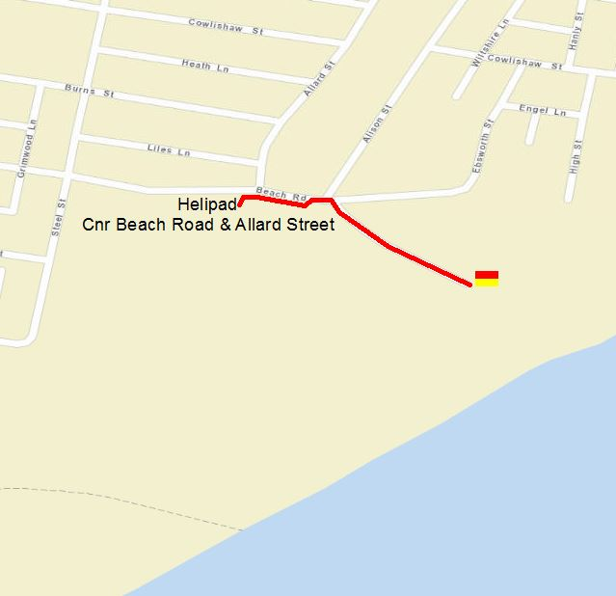
Emergency rally point location: Helicopter Landing Pad
Cnr of Beach Road and Allard Street
Redhead

Alternatively Parkland at top of car park

Helicopter Landing Zone
During major incidents, rescue helicopters may be required to land on the beach or near the beach to assist treating the patient and possibly transporting the patient to hospital. Ultimately, the decision of where to land is made by the pilot of the aircraft based on weather conditions, the nature of the incident and surrounding hazards. Patrol Captains can prepare and suggest a landing zone using local knowledge prior to a helicopter arriving.
Things to consider when establishing a helicopter landing zone;
- 40m x 40m area (minimum)
- Flat and cleared of hazards (loose objects, power lines, trees, etc)
- Helicopter will approach the landing zone against the wind
Helicopter Landing Zone procedure;
- Nominate a suitable lifesaver as ‘landing zone controller’ and provide a radio
- ‘Landing zone controller’ briefs lifesavers on pre-landing and post-landing procedures
- Landing zone cleared of all loose objects, vehicles and people
- Landing zone established with minimum 40m x 40m area and marked with cones.
  - Lifesavers to ensure landing zone is maintained and members of the public do not enter the area
  - ‘Landing zone controller’ is to be positioned on the side of the landing zone that the helicopter will land towards
- Establish contact with helicopter of ‘Surf Channel 1’ prior to landing and confirm suitability of landing zone. Provide a summary of key hazards (trees, power lines) within the area
- Helicopter lands, lifesavers ensure perimeter is maintained until helicopter departs
- Do not approach the helicopter and await instructions from the helicopter crew (only approach the helicopter from the front and once given the all clear from the helicopter crew)
- Ensure loose objects are secured and landing zone is clear of people prior to helicopter taking off
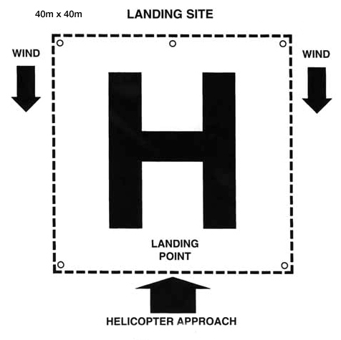

Standard Operating Procedures
For detailed information on Lifesaving procedures and policies, refer to the Standard Operating Procedures on the Surf Life Saving New South Wales website.
- LS1 Work health and Safety
- LS2 Information Management
- LS3 Obligations and Standards
- LS4 Regulations – Rescue Vessels
- LS5 Gear and Equipment
- LS6 Radio Communications
- LS7 Patrol Operations (general)
- LS8 Patrol Operations (emergency)
- LS9 Emergency Response System
- LS10 SAR Operations
- LS11 SurfComs
- LS12 Lifesaving Vessels and Aircraft
- LS13 Post Incident (recovery phase)

6. Excerpt Beach Lifeguard Services Operational Manual
SECTION 1.7.6 INCIDENT RESPONSE
Suspected and Confirmed Shark Sighting Procedure
This section identifies essential tasks to enable the Unit Lifeguards to efficiently manage a Suspected and Confirmed Shark sighting incident at a patrolled Council beach. The report of a shark sighting may be made by a range of sources lifeguard/lifesaver, swimmer, surfer, aerial survey or any beach user.
In the case of a shark attack proceed as per SECTION 16 of the Beach Lifeguard Services – Beaches Emergency Response Plan.
Containment
Patrolling lifeguards
- Responsible for initial confirmation and gathering of information on report of a suspected/confirmed sighting. Assess information and determine whether sighting is a suspected shark sighting or confirmed shark sighting.
- Information includes: Who made the sighting, where and when was the sighting, number of sharks, how far offshore, proximity to swimmers/surfers/surf craft users, how long did the sighting last and approximate size?
- The time and location of sighting in relation to the primary and secondary patrol area.
- Suspected sighting definition – an object identified within patrolled area (primary or secondary), details may not conform to shark behaviour/descriptions or source of information may not be considered completely valid or accurate. Generally speaking is a sighting made by an individual that has not received some level of training or does not have significant experience with marine life, or cannot be verified in some way as credible
- Confirmed sighting definition – object identified within patrolled area (primary or secondary), details of sighting aligns with description/behaviour of shark and/or source appears reliable/confident. Generally speaking is a sighting that is a visual by a lifeguard, trained staff, public official, sightings made by multiple persons, or other highly credible sources. It may also be any sighting that based on the information and evaluation is deemed to have a high level of credibility.
Suspected Shark Sighting Actions
- Close beach as per SOP and evacuate public from water remotely using whistle, hand signals, vocal commands, etc.
- Lifeguards ready PWC for launch and Lifeguard #1 conduct search in a sweeping pattern and evacuate remaining public from water in primary patrol area.
- Second Lifeguard Contact Beach Lifeguard Team Leader (BLTL) to advise of suspected sighting and decision to close beach temporarily. Maintain contact with Lifeguard #1 at all times via 2way radio.
- Once primary patrol area is cleared of patrons, sweep of secondary patrols area undertaken including advising surfers, whilst maintaining vigilance on primary patrolled area.
- Lifeguard # 2 is to advise neighbouring patrolled beaches and deploy to an elevated position (tower/upper level of surf club) to monitor the water with binoculars.
- If attending Lifeguard #1 or #2 confirms shark sighting, follow confirmed shark sighting procedure.
- If sighting not confirmed after search (1 hour), Lifeguards may reopen and resume normal operations.
- All appropriate paperwork is to be completed.
Confirmed Shark Sighting
- Initiate emergency siren, close beach as per SOP and evacuate public from water remotely using whistle, horn, hand signals, vocal commands, etc.
- Lifeguards ready PWC for launch and Lifeguard #1 conduct search in a sweeping pattern and evacuate remaining public from water in primary patrol area.
- Second Contact Beach Lifeguard Team Leader (BLTL) to advise of confirmed sighting and decision to close beach temporarily. Maintain contact with Lifeguard #1 at all times via 2way radio.
- Once primary patrol area is cleared of patrons, sweep of secondary patrols area undertaken, including advising surfers within site area whilst maintaining vigilance on primary patrolled area
- Lifeguard #2 erect Shark Warning sign next to Red Flag/Beach Closed sign
- Lifeguard # 2 is to advise neighbouring patrolled beaches and is then deployed to an elevated position (tower/upper level of surf club) to monitor the water with binoculars and maintain reasonable contact with public regarding the circumstances of the closure
- If visual contact is made during search, the Lifeguard operating PWC should consider trying to herd the shark out to sea or shadow the shark and its location from an appropriate distance (minimum 15 metres).
- Lifeguard #1 is to continue PWC sweep for 1 hour following last sighting.
- If no further sighting is confirmed after;
- 1 hour search period in sunny clear conditions with little surface water disturbance and water turbidity, the PWC is to return to shore.
- 2 hour search period should be conducted during periods of low light due to cloud cover, poor water clarity, medium to high level water turbidity due to wind chop or large surf conditions. Lifeguards may then reopen and resume normal operations.
- Once reopened Lifeguard to conduct a search for a minimum 30 mins behind the break as a precautionary measure and 1 hour from an elevated position (tower/surf club).
- All appropriate paperwork is to be complete including DPI Shark Sighting report as per the NSW Shark Incident Response Plan.
Second Lifeguard
- Provide immediate support to attending Lifeguard.
- Provide assistance loading/unloading the PWC.
- If not already completed, close beach as per SOP as required.
- If confirmed sighting, erect Shark sign next to Red Flag/Beach Closed sign.
- Contact is made with adjoining beaches.
- Contact Beach Lifeguards Team Leader.
- Maintain reasonable contact with public regarding the circumstances.
- Remain vigilant from a viewing position.
Third Lifeguard, if available
- as per generic responsibilities.
Reduction
- Continue to monitor surf zone.
- Ensure all public are aware and removed from perceived risk.
- Lifeguards where appropriate should educate bystanders and members of the public about LMCC Shark sighting procedural details and direct them to DPI Shark Smart website, www.dpi.nsw.gov.au/fisheries/info/sharksmart for further information about the ways to reduce their chances of an encounter. All media enquiries need to be directed to Council administration building.
- Contact Beach Lifeguard Team Leader.
- Return venue to normal use once pre-determined amount of time has elapsed (1 hour or 2 hours in specified conditions) to reduce risk, and no sharks have been sighted within the period of closed beach, they may resume normal operating procedures. During unusual or exceptional circumstances the Beach Team Leader is contact Leisure Services Operations Coordinator or Manager Leisure Services.
Elimination
- Elimination of shark encounters and sightings is not possible. Post incident review with all staff involved and any suggested continuous improvement actions to be discussed with Beach Lifeguard Team Leader in the first instance.
Recording
- Complete reports as required including DPI Shark Sighting report as per the NSW Shark Incident Response Plan.
---------------------------------------------------------------------------------------------------------
SECTION 16: Beach Lifeguard Services – Beaches Emergency Response Plan
Major Bleeding & Tissue Damage: Eg Shark Attack / Power Boat Injuries
This section identifies essential tasks to enable the Unit lifeguards manage effectively and efficiently an incident involving major bleeding and tissue damage at the beach.
Note: If a shark attack:
- Remove all swimmers from the water immediately and close beach
- Do not attempt to swim to the aid of the shark attack victim
- Use an IRB/PWC which provides a safer environment for the lifeguards while the rescue is being made
- While approaching the victim avoid splashing, quick and erratic movements, and most importantly, avoid panic utilising controlled breathing training techniques.
Containment
Attending Lifeguard/s
- Contact emergency services
- Bring the patient to the beach as quickly as possible – using boards, IRB/PWC etc
- Do not waste time trying to control bleeding in the water
- Carry patient above waterline
- If conscious:
  - Keep head level with heart and elevate legs
  - Keep warm by covering with a blanket but do not overheat
  - Moving patient must be kept to an absolute minimum

- If unconscious
  - Turn patient on side, care for ABC and prevent further loss of blood
- Attempt to stop bleeding by direct pressure
- If unsuccessful, use an arterial tourniquet.
- Patient will need to be stabilised at beach by medical team
- Moisten patients lips, but do not give anything by mouth
- Administer oxygen therapy
- Continue to monitor and control bleeding until emergency services arrive
Senior Lifeguard
- Ensure that emergency services have been contacted
- Advise adjacent beaches and team leader

Team Leader
- If a shark attack notify Police and DPI – Manager Special Operations / Director Fisheries Compliance and consider closure of patrolled and un-patrolled beaches in conjunction with Leisure Services Manager initiate reduction measures
Reduction
- Continue activities to reduce impact of emergency, including:
  - Public safety - if shark attack ensure that public are kept out of the water.
  - Delegate responsible member of the general public to meet emergency services upon arrival and direct to incident scene.
  - Delegate responsible members of the general public to control bystanders and keep a clear path for the Emergency Vehicles

- Team Leader to contact Police and DPI – Manager Special Operations / Director Fisheries Compliance.
- Police and DPI – Manager Special Operations / Director Fisheries Compliance and LMCC consider when appropriate to re-open the beach.
- Initiate recovery procedures.
Elimination
- Post incident review with staff
- Initiation of HINCS reporting system if required
- Post-event trauma counselling
- Post event debrief with relevant staff and representatives from NSW Police and DPI
Recording
- Complete reports as required including Dpeartment of Primary Industries (Fisheries) Shark Bite Information Sheet as per DPI Shark Incident Response Plan

